
Course Title: | Artificial Intelligence (Lab) |  |  |  | Course Code: |  | CAI-601400 | Credit Hours | 1
Instructor: | Rasikh Ali |  |  |  | Program: |  | BSAI
Semester: | 3rd | Batch: | Morning | Section: | 3A |  | Date: | 19th April, 2026
Time Allowed: | Week 13 |  |  |  | Maximum Marks: |  |  | 20
Student’s Name: | Muhammad Qasim Ashfaq |  |  |  | Reg.No. | SU92-BSAIM-S25-030

The Superior University, Lahore
SEMESTER PROJECT

Project Title: Medical Health Insurance Cost Prediction System

Department of Software Engineering


The project is based on a Machine Learning Model that predicts the Annual Medical Insurance Cost on the basis of features such as Age , Gender , BMI (body mass index) , Smoking status , Diabetes , Hypertension , Cardiac Health , Asthma , Physical Activity Status , Step Count , Sleeping Hours , Medication Count , Hospital Admissions , Doctor Visits per year , Stress level and City type.

Role of Age in Prediction:
Age plays a Vital role in determining the overall physical state of a person . A young person may not need immediate medical attention as compared to the older person as their physique tends to deteriorate with time. This heavily affects the overall estimation of medical bills and so does the insurance price.

Role of BMI in Prediction:
Body Mass Index is the measure of body fat based on height and weight that applies to adult men and women.
BMI = mass in Kg / height in meter
Though it has some demerits, for example , the exclusion of bone density and muscle weight, it does overall put an impact on the Insurance Bills.

Smoking Status and its Role:
Smoking puts a person’s health at high risk and the fact that a person smokes , alone, puts the medical bills at severely high risk. It not only affects health but also shoots up the predicted costs, showing high correlation with the predicted results.

Binary Representations:
Some categories like Diabetes , Asthma , Hypertension etcetera are based on Binary Values (1 for True and 0 for False). These Columns then merge to form a Health Risk Status column to further enhance the prediction results.

Subordinate Features:
Features such as Sleep Hours , Step Counts , Doctor Visits per year and City Type are commonly used when something is important but not widely regarded as useful when it comes to medical Cost Prediction.

The Shape of the dataset can be found using data.shape that comes out to be (5000 , 20)
Rows = 5000
Columns = 20
Columns Represent the Features and Rows represents the values inside each of the Features.

Importing Libraries:
Before any Exploratory analysis , the following important Python Libraries were imported in the notebook file:
- Scikit_learn
- Matplotlib.pyplot
- Pickle
- Pandas
- NumPy
- Plotly.express
- Seaborn

The Dataset had 1048 Null Values in the “Insurance-Type” column . It was filled using :
- data[‘insurance_type’] = data[‘insurance_type’].fillna(data[‘insurance_type’].mode())

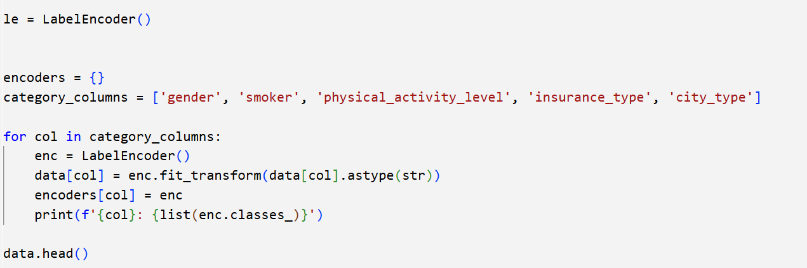
To start the Cleaning Process , we need to encode the string values of our dataset into Integers with a certain code. Manually this process would take hours, so we use a library called “scikit_learn” to label encode the string values.

Encoders Dictionary:
“The Encoders are components that convert user input like text , images or categorical data into a compact and numerical data for the computer to perform operations successfully”
- One-Hot Encoding converts Categories to Binary Columns
- Label Encoding assigns numerical values to categories
Basically, they help the model to understand the user’s non numeric data input.

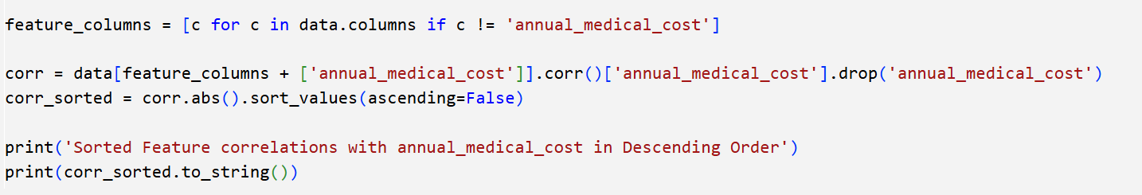
Which features affect the Predictions with the greatest impact. To find this out , we use correlation.

The Higher the value , the bigger the Correlation. It’s important to know that correlation values range between 0 and 1.

In this Dataset :
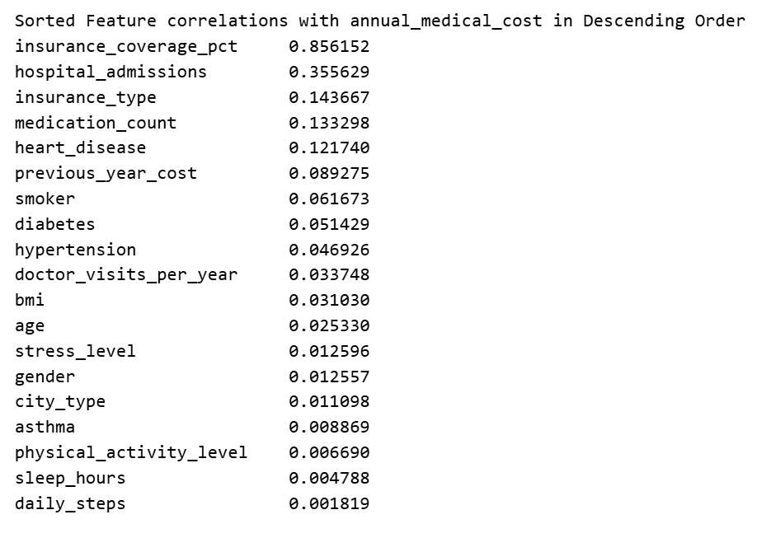

Visual Representation of Correlation
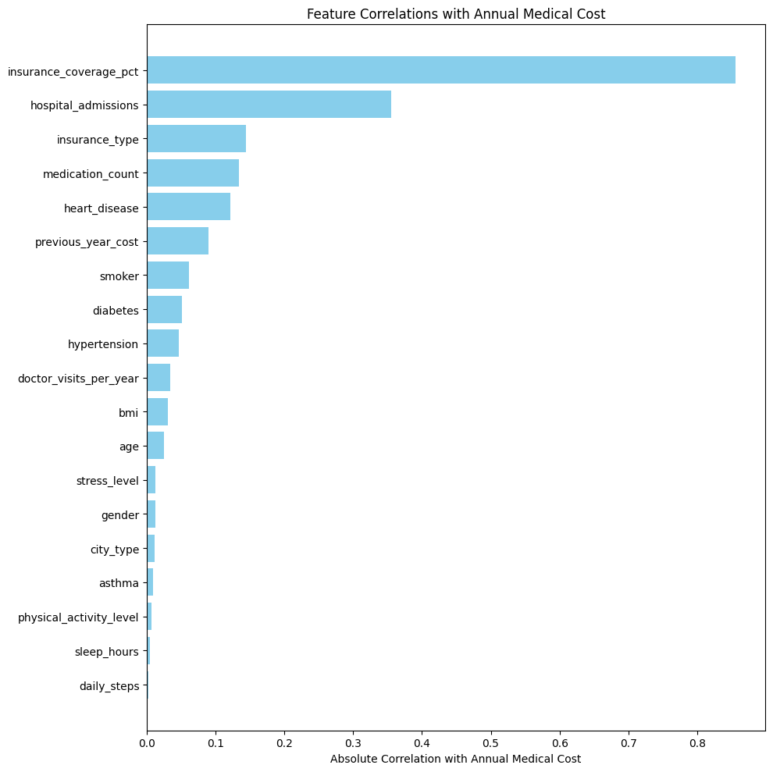
This Visual Representation of Correlation of dataset features with the medical insurance cost prediction results can be generated by many libraries such as Plotly , Seaborn , Matplotlib. In this instance , Matplotlib is used for this purpose.

The Next Step Involves the selection of best features ( the features that affect the prediction values the most ) which has the highest correlation values among all .

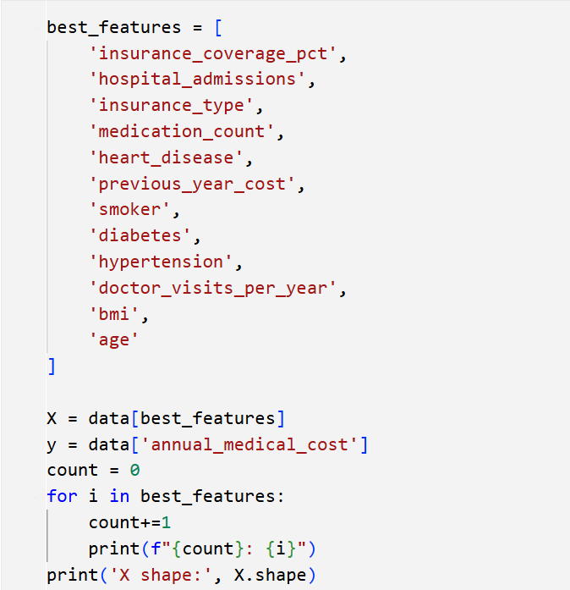

Output:

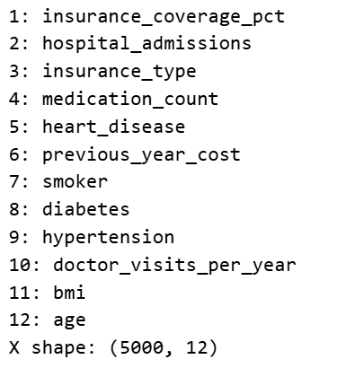
These 12 Features are extracted from the 20 features which were included in the dataset initially. Now based on these features , the model will be trained.

Training the Model
First of all, the dataset is splitted into two portions , one for the training purpose and the other for the testing purpose.

Building the Model:
A Gradient Boosting Regressor is an ensemble machine learning technique that builds a strong predictive model by sequentially training weak regression trees, where each new tree corrects the errors (residuals) of previous trees. It is highly accurate for complex regression tasks, offering flexibility in optimizing different error metrics like mean squared error (MSE) or absolute error.
For this project , I have used the Gradient Boosting Regressor.
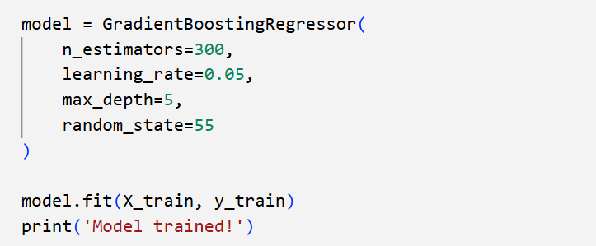

Explanation:
- n_estimators are the number of trees in total
- learning_rate defines how much each tree contributes to the final prediction
- max_depth limits how deep a tree goes
- random_state just shuffles the data and nothing more

Accuracy is important for a model as it determines how close the predictions are to the actual cost. For testing Purposes, we use Mean Square Error and R² Score. The R² Score tells us that out of 100 , how much percentage of results are accurate. While the mean square error tells us how much closer the predicted values are to the mean value of the actual costs.
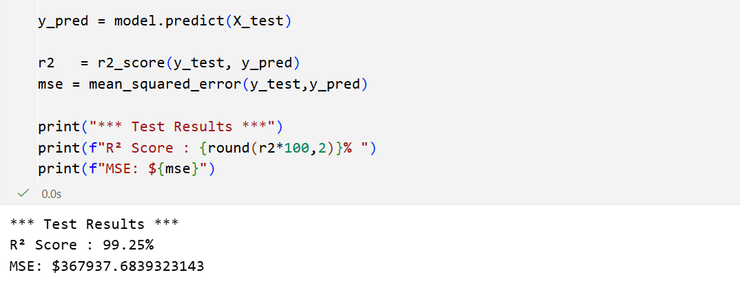
The 99.25% Accuracy makes this model extremely close to being perfect in predicting the medical insurance costs.

Actual vs Predicted Plot:
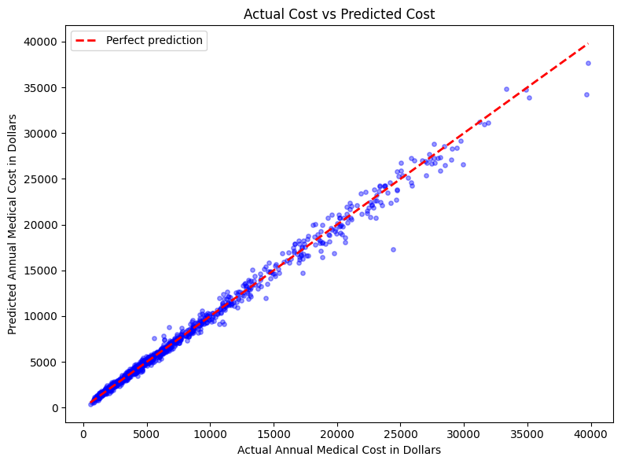

Saving the Model using Pickle:
To avoid the interpreter training the model each time the program is ran , pickle or joblib is used. They essentially convert the trained model into a binary file inside the local memory so that once the training process ends , the model can be run almost immediately without time delays and interruptions.
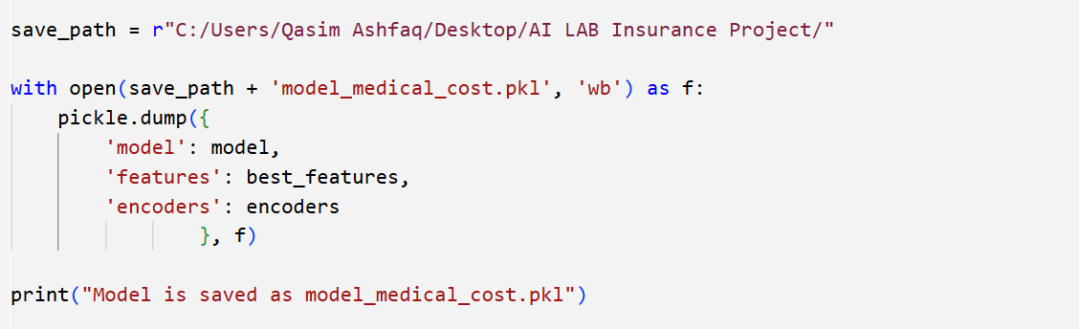

Streamlit Integration
To make the regression model accessible and interactive, a web-based user interface was developed using Streamlit. This would allow users to input feature variables directly and receive real-time regression predictions without interacting with the backend code.

Procedure:
To run the main “streamlit web interface” named as “medical_cost_app.py” you need to open the terminal and then change the directory to the folder where the model is present. Then Run the command “streamlit run medical_cost_app.py” and it would open the web Interface.
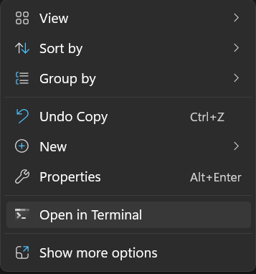
Step 1: Move to the Folder containing all the files
Step 2: Right Click and press on “Open in Terminal”
Step 3: Run the Command “streamlit run medical_cost_app.py”

User Interface Snippets
Page 1)
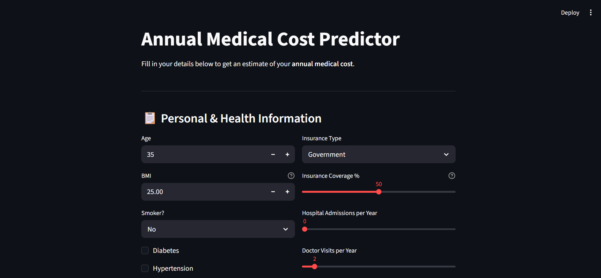
Page 2)
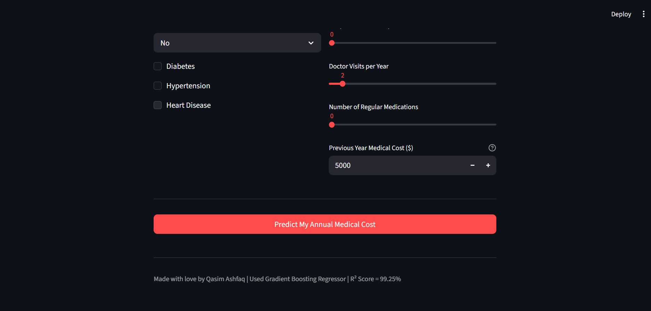

Results after Prediction:

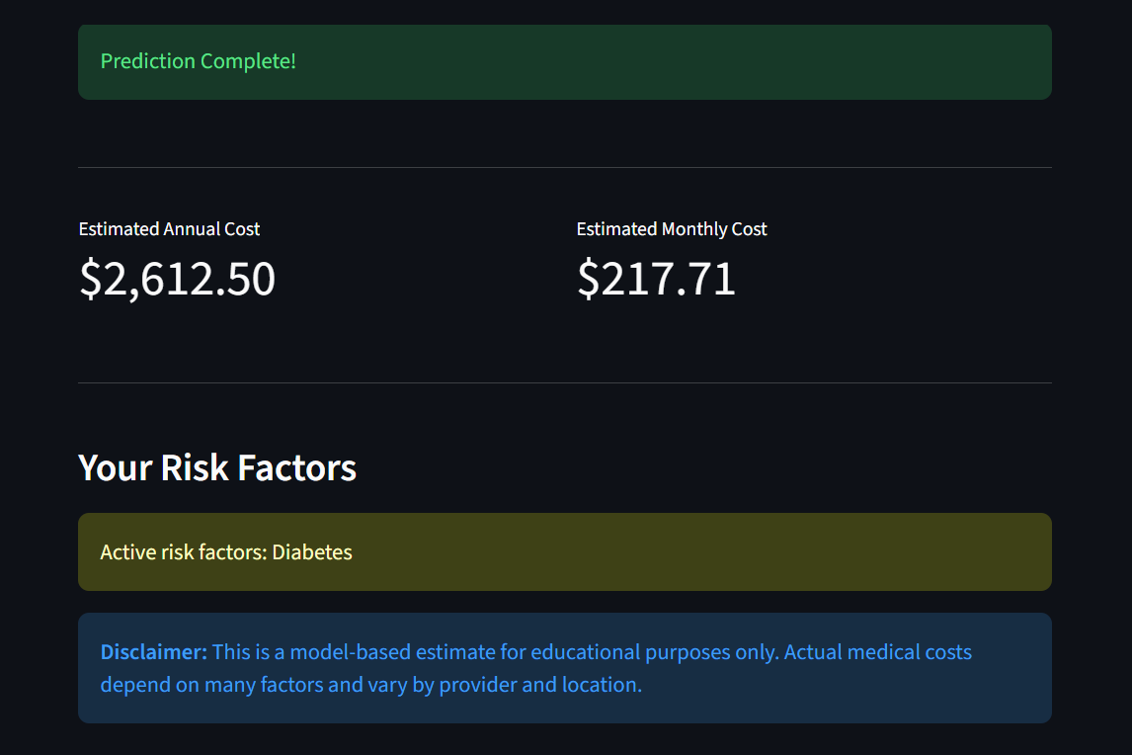

Disclaimer : This isn’t an official statement from any Health Insurance providing Facility , it’s an educational purpose model for cost estimation and it should not be involved in any legal or illegal purposes.

Dataset Reference:

Kaggle

